Sprint 3 Plan

Plan-it

Team Rocket

11/17/2019

Revision 1, 11/6/2019

<https://app.clubhouse.io/teamrock/epic/37/plan-it?label_ids=81>

High level goal: *Allow users to save a printable version of their activity plans, and generate plans that more closely fit their specifications.*

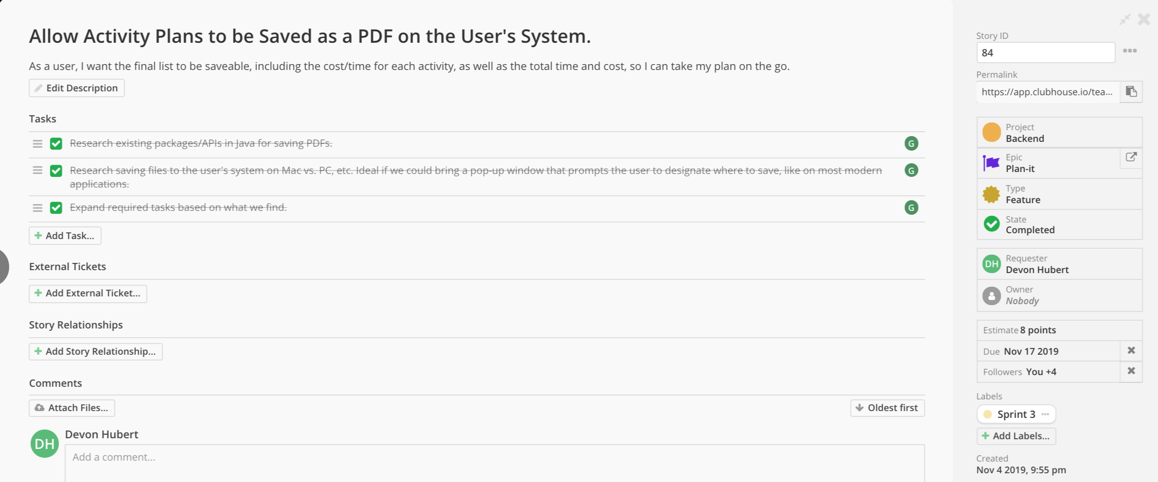

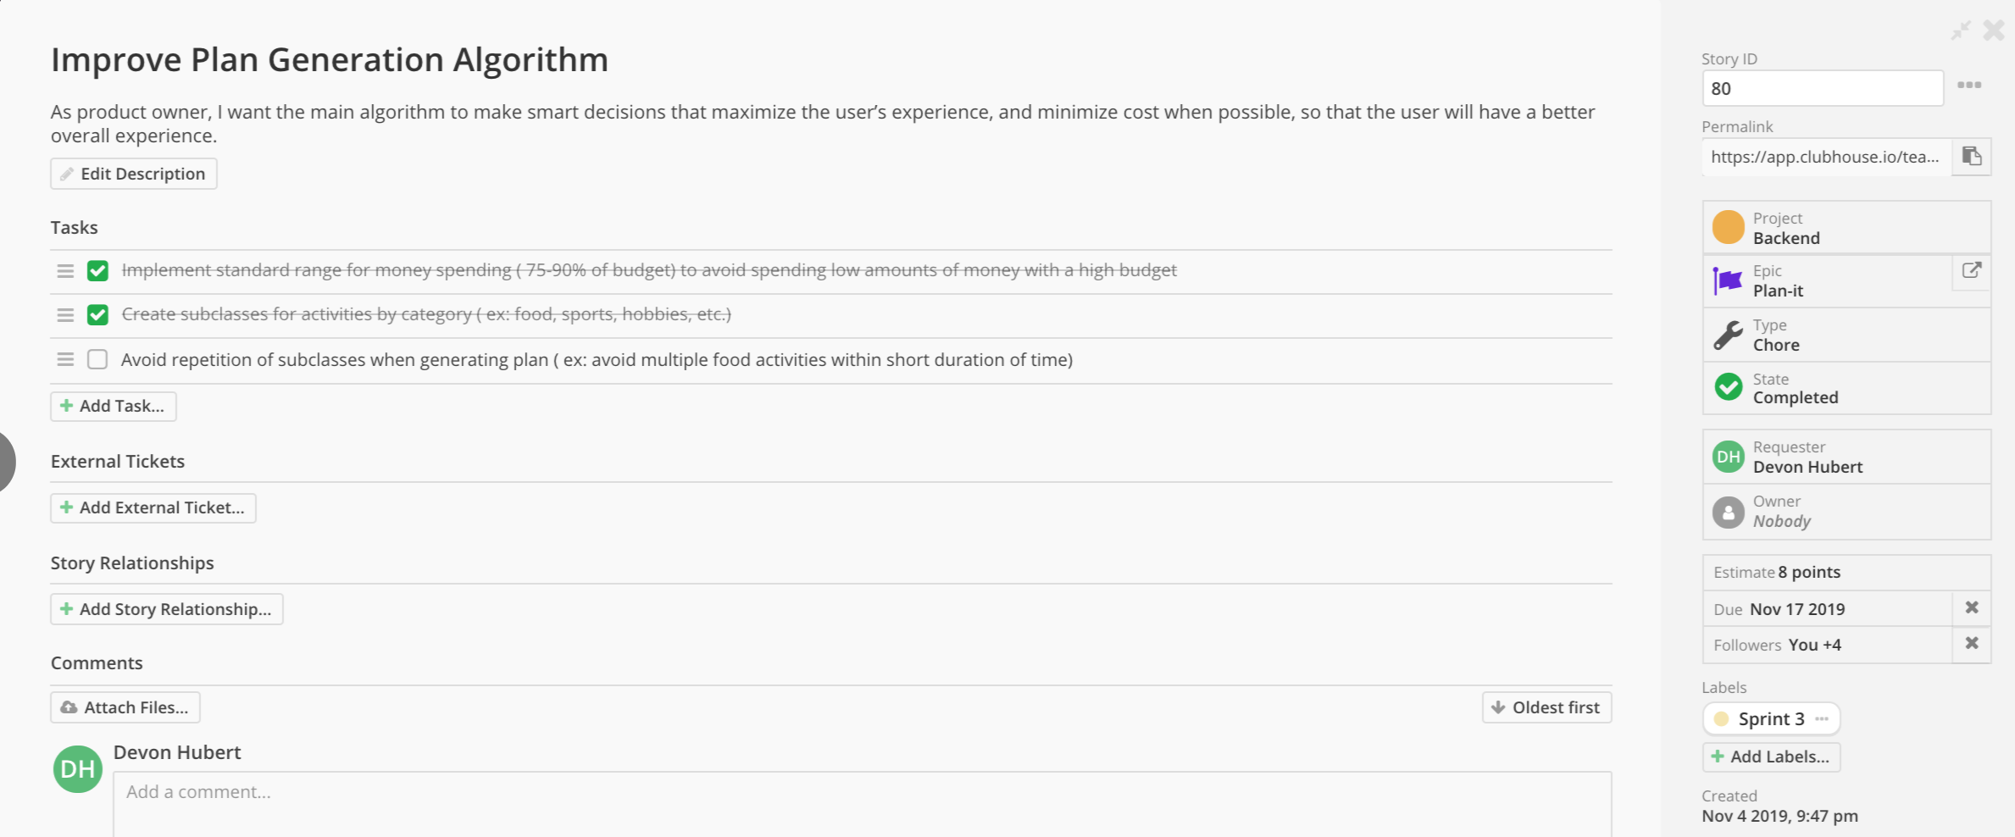

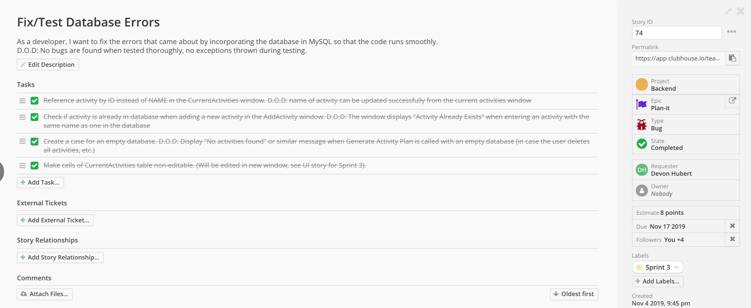

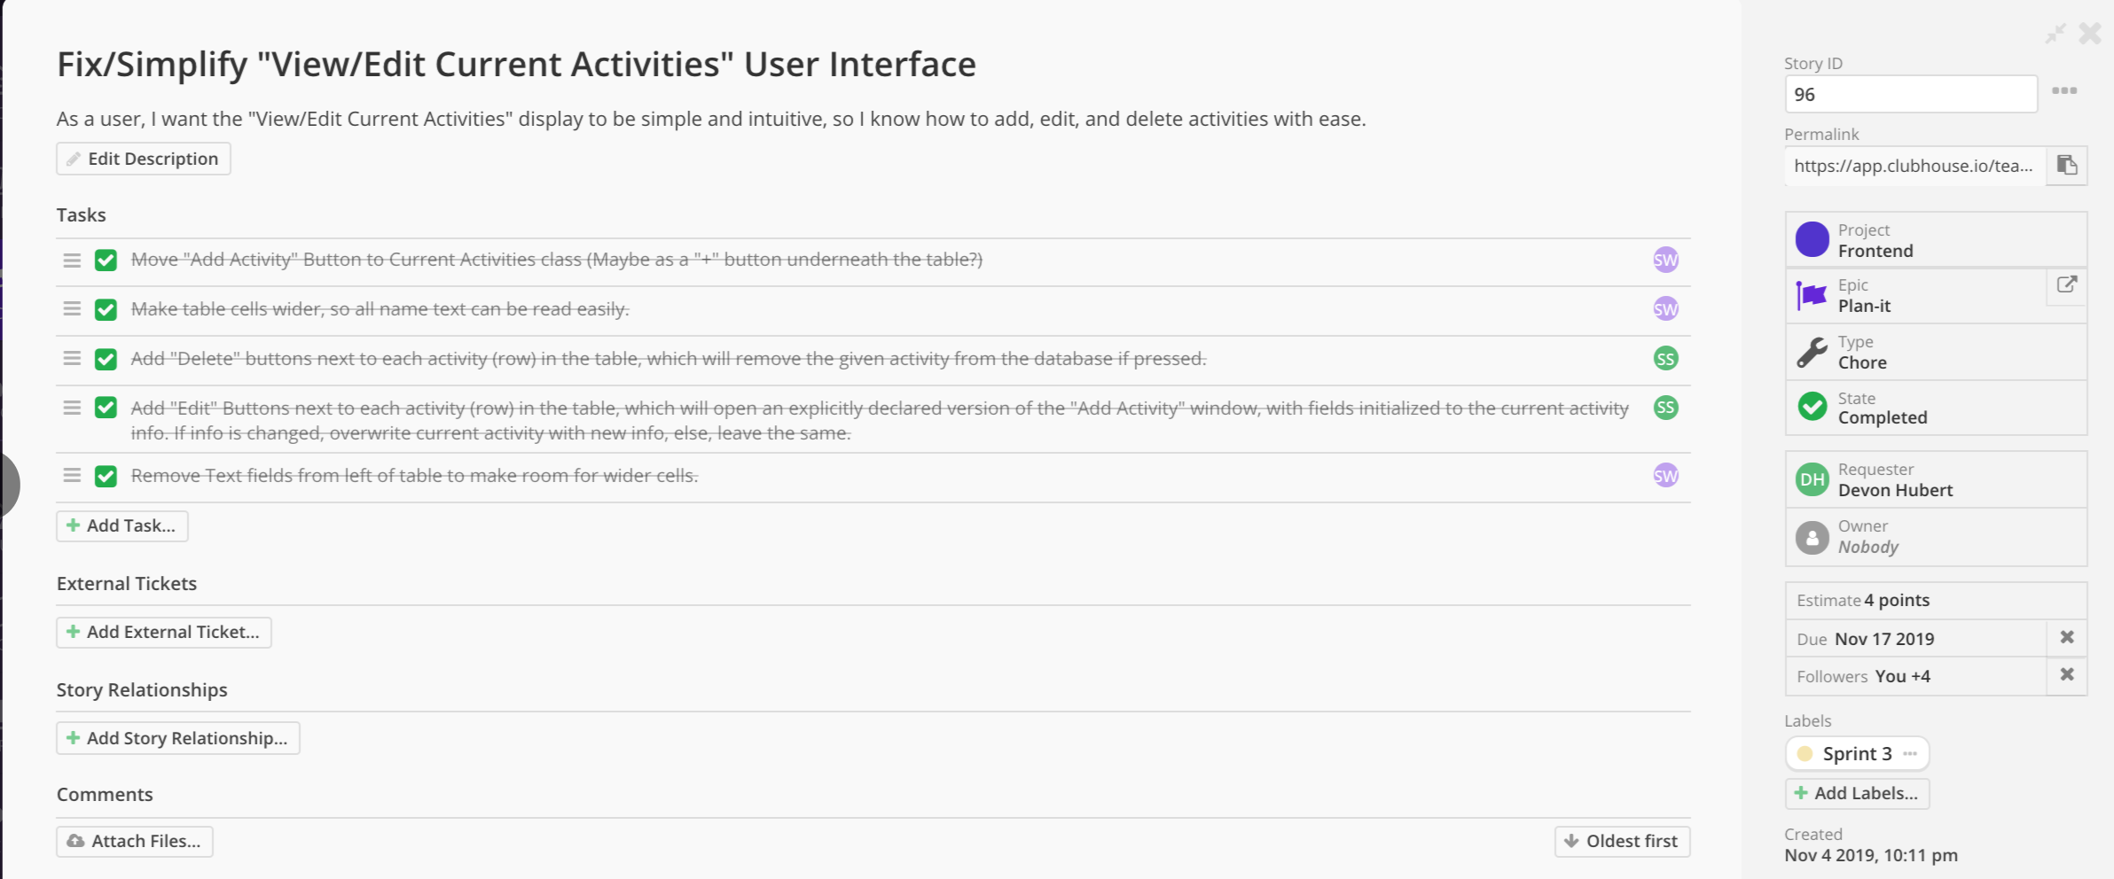

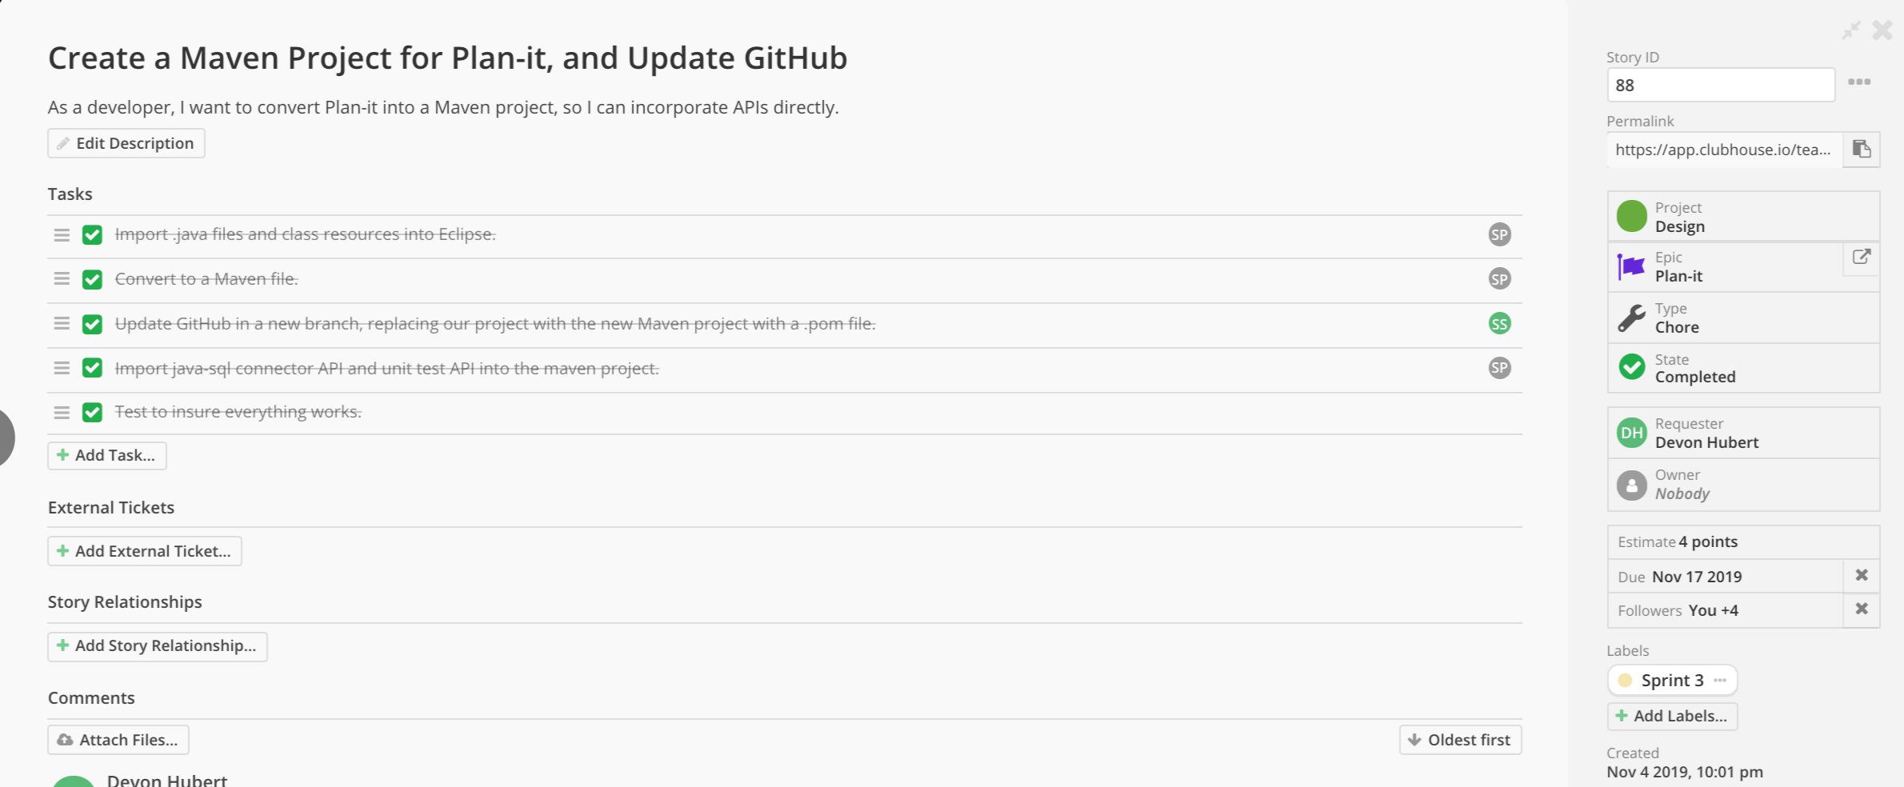

Meeting times: Monday, Wednesday, and Friday at 11:30. TA meeting on Wednesdays at 10:30 in room 316.